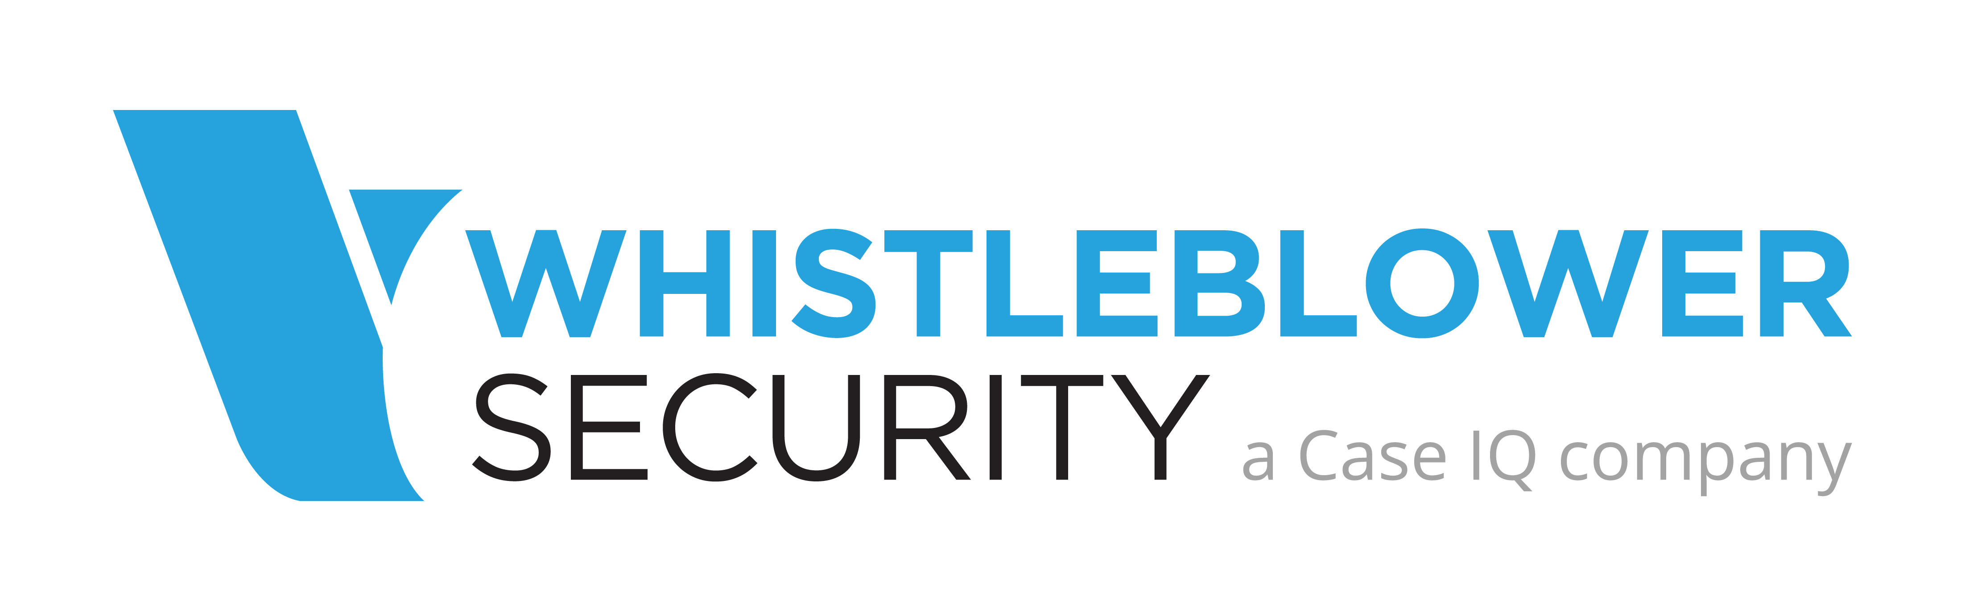

Creating the WhistleBlower Ethics Hotline Communications Plan

Define the goals of the organization:
- Employee empowerment
- Governance
- Risk Mitigation
- Human Resources development & coaching

Ensure you have considered your organizations values and beliefs and incorporate those into any communications that you share with your team.

Draft the plan to meet the goals of your organization and reinforce the organization’s values.

- Enhance the visibility and reputation of the organization
- Generating both positive and forthright feedback from staff and other stakeholders – ie vendors
- Changing attitudes and encouraging empowerment
- People can prevent forest fires – the whistleblower system can prevent or mitigate potential disasters.

Six Critical Elements in Designing the Plan
- Understand your audience and the best message to reach them
- Determine your key messages – improving the culture, increasing avenues of communications, more oversight
- Determine key materials to be produced (code of conduct, videos, letter from the CEO, etc)
- Obtain resources
- Develop your written plan

Developing Effective Materials
- One page fact sheet
- Inclusion in Employee/HR handbook
- Inclusion in the organizational intranet/SharePoint/etc.
- Posters in staff rooms, restrooms, lobbies and wallet cards for every employee
- Lunch and Learns using actual incidents or ethical dilemmas
- Annual review and sign off of Code of Ethics
- Branded collateral, - pens, stickers for back of name tags

Ensure Consistent Communications and Messaging
- Ensure consistent messaging from the CEO through management
- Promote dialogue about availability and support of management
- Ensure middle management adheres to tone
- Share sanitized case studies
- Use lunch and learns
- Share statistics of usage
- Consider inclusion of hotline on cheque stubs
- Always review ethics/whistleblower policy annually during performance appraisals
- Consider having CEO thanking whistleblower when they make a report

